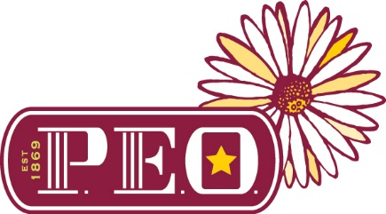
Chapter E PEO Scholarship
Chapter E PEO is a philanthropic educational organization that would like to award a $500 scholarship to a Vermillion High School female student who plans on attending an accredited college or technical school. We anticipate awarding multiple scholarships. The scholarship(s) will be awarded based on academic achievement as well as character, community involvement, work ethic, and school involvement.
Please complete this form with a copy of your transcript and ACT or SAT scores and return it to the Vermillion High School Guidance Office by April 11, 2025. ACT or SAT scores are not necessary if you are planning to attend a technical school.

Name of Applicant: ____________________________________________________________________________
Current Address: ____________________________________________________________________________
Name of PEO Chapter: Chapter E, Vermillion, SD_____________________________________
Total Credit Hours and GPA: ____________________________________________________________________________
Post-Secondary Institution you plan to attend: ____________________________________________________________________________

1.List special honors you have received: You may attach an additional page for any answers below.

2. What activities did you participated in while in high school:

3. How have you contributed to church, community, or charitable organizations in your community:

4. Comment on any facts about you, or any special conditions to be considered by Chapter E PEO.

5. In 50 words or less, write a brief description or statement of purpose of why you have chosen to further your education and what your goals are when completing your higher education.

6. List three references: Please, no family members.
Name: Position Address________
1.
2.
3.
Reminder: Applicants should submit a copy of their transcript complete with ACT or SAT scores with this application form.

Signature ________________________________________ Date _______________________
$500 scholarship. Application due by April 11, 2025.

