PEO Chapter BL of Vermillion
Local Scholarship Award Guidelines and Form
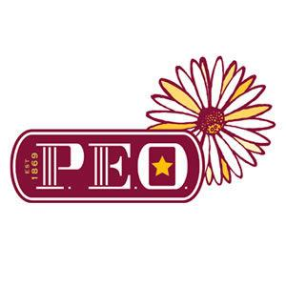
P.E.O. (Philanthropic Education Organization) is an organization in which women celebrate the advancement of women through scholarships, grants, awards, loans and stewardship of Cottey College (Nevada, MO); and motivate each other to achieve their highest aspirations.

Chapter BL of Vermillion will award one $500 Scholarship to a graduate of Vermillion High School who plans to attend an accredited college or technical school in the fall following their senior year. The Scholarship will be awarded to a female student based on not only academic achievement but character, hard work, community outreach event/organization and past/present employment.

Please submit the completed scholarship application, a copy of your H.S. transcript (does not need to be certified) and one letter of recommendation to either the Guidance Office at Vermillion High School, email or regular by Tuesday 2 April, 2024 (further guidance is provided on the next page). The name and address of at least one College or Technical School that you plan to attend must also be provided.

If you have any questions please contact us at: ines.n.white@gmail.com or call/text (605)-670-9436

For more information on Cottey College, Nevada MO please visit: www.cottey.edu
Cottey College is owned and supported by P.E.O.

*This Scholarship is open to all female High School Senior students, and is not based on being related to any member(s) of a PEO Chapter.

PEO Chapter BL of Vermillion Scholarship Application

Name:__________________________________________________________
Date of Birth:____________________________________________________
Mailing Address:_________________________________________________
Cell Phone:______________________________________________________
Personal E-Mail Address:___________________________________________
Ensure email address provided is not your school email. Only your Personal E-mail will be accepted.
Requirements/Guidelines:
- Please answer the following questions in paragraph form. You may submit responses in two forms; handwritten in the space provided on this form or in a separate typed document.
- Enclose one letter of recommendation (from a person unrelated to you).
- One copy of your H.S. Transcript.
- Return completed application form and letter of recommendation NLT Tuesday 2 April, 2024. to either:
  - The VHS Guidance Office
  - Emailed to: ines.n.white@gmail.com
  - By regular mail to: 501 S. Crawford Rd, Vermillion, SD 57069

- What are your educational and career goals? Please include the name of the college/university/technical school you plan to attend.

- What is special about your hometown, are there things you like/love or would like to see in your community?

- Describe at least one way you have contributed to a community event/outreach and organization. Or describe a past/present employment which you found fulfilling.

- Can you tell us about one person who has made a major impact in your life and why? Has this person influenced your career choice in any way?

- Describe a challenge/difficulty which you have experienced and how you were able to work through it or overcome it. (Feel free to continue on another page).

